Project Increment-4



Tech Roos Team (Aditya Deshpande, Tej Kiran Meka,

Rakesh Reddy Kondikindi, Giresh Babu Yemparala)

**Import Existing Services/API:**

In increment 4 we used Host API that detects the location of the donors by tracking through their IP address of the system. We used Google Maps API for displaying the nearby organizations and events based on the location of the donor.

**Class Diagram:**



**Sequence Diagram:**



**Screen Shots:**

If a donor or organization forget his password then he can reset and later change password through this feature.

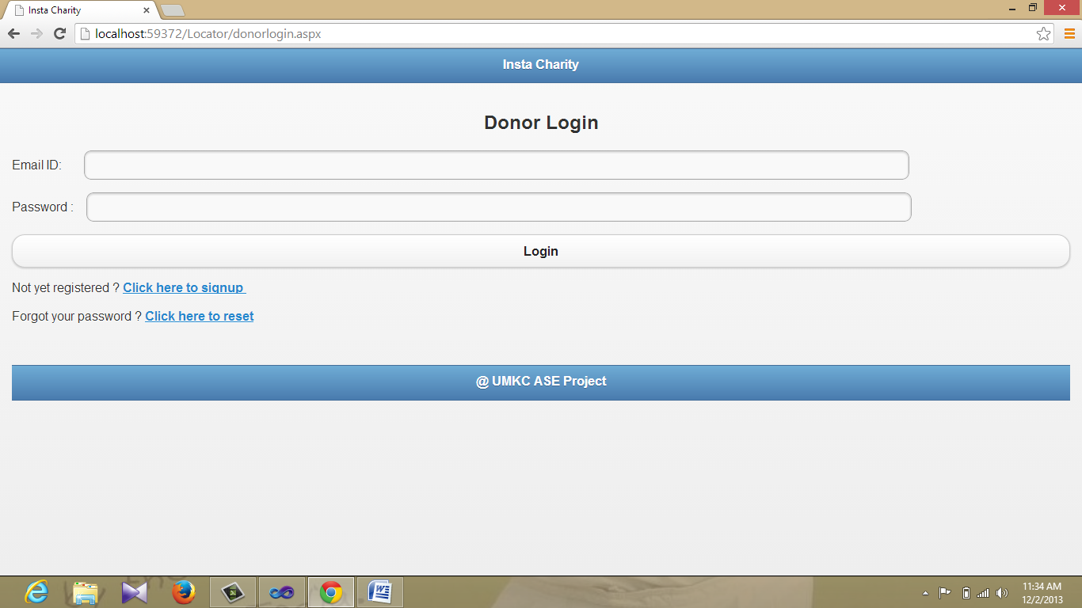

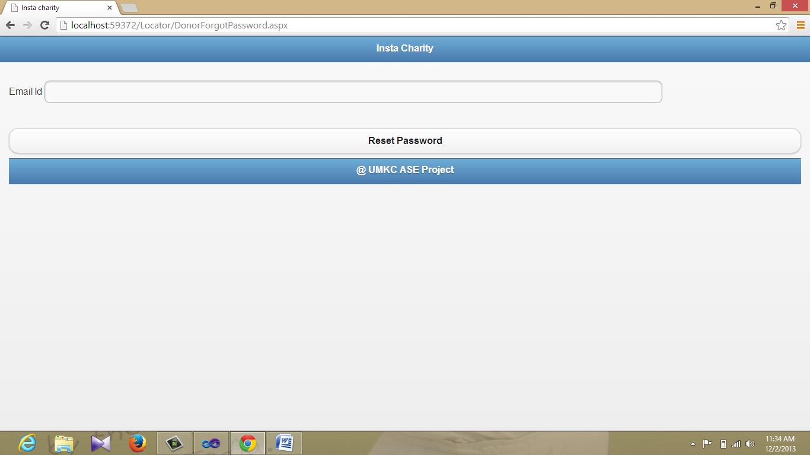

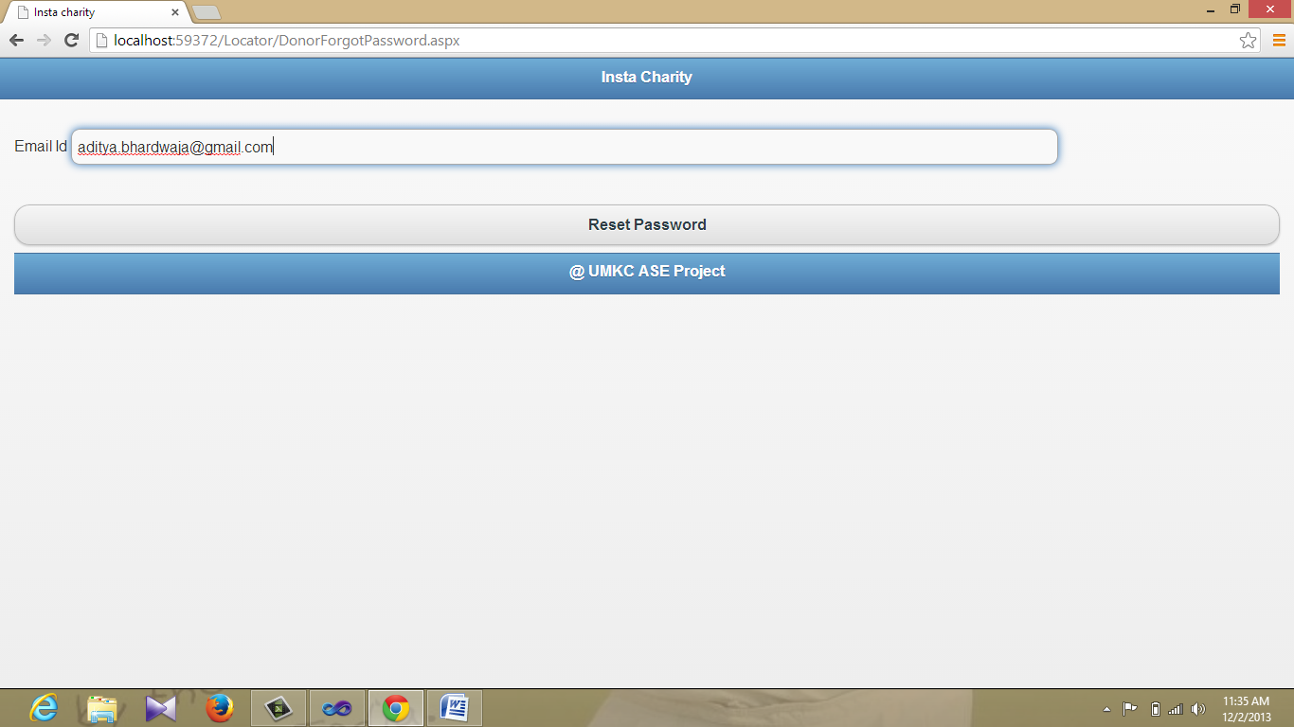

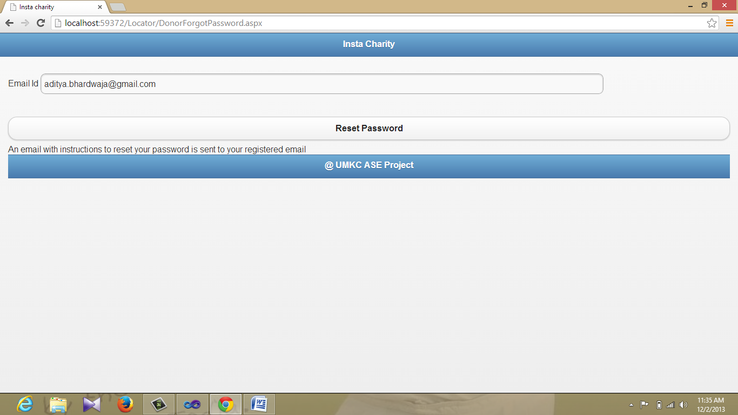

Password reset link with an uniqued id will be sent to the email address of donor or register.

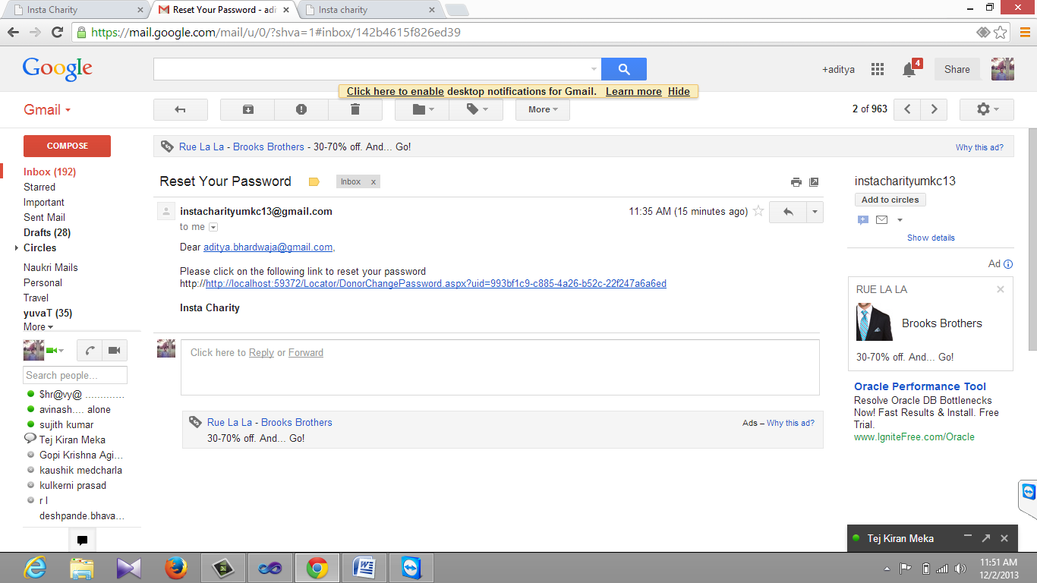

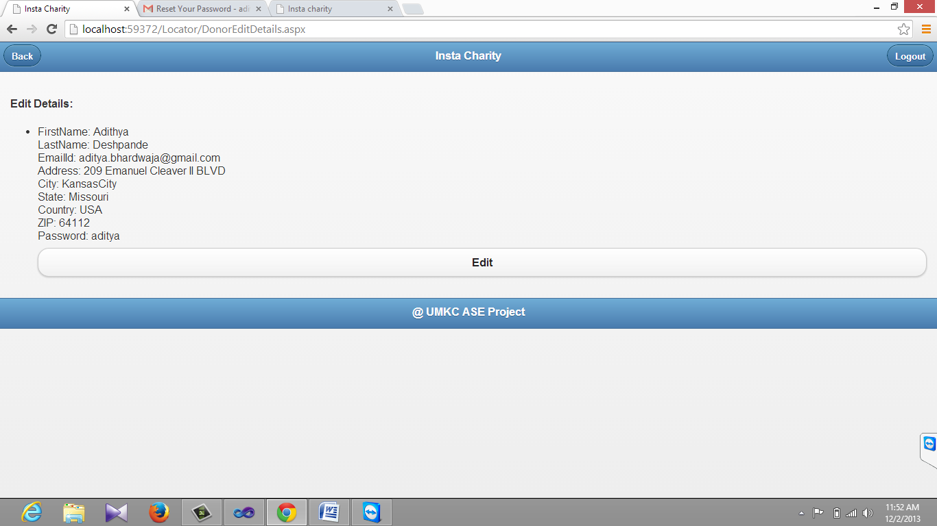

Above screen shot is the image of the details of profile in donor's page before reset the password

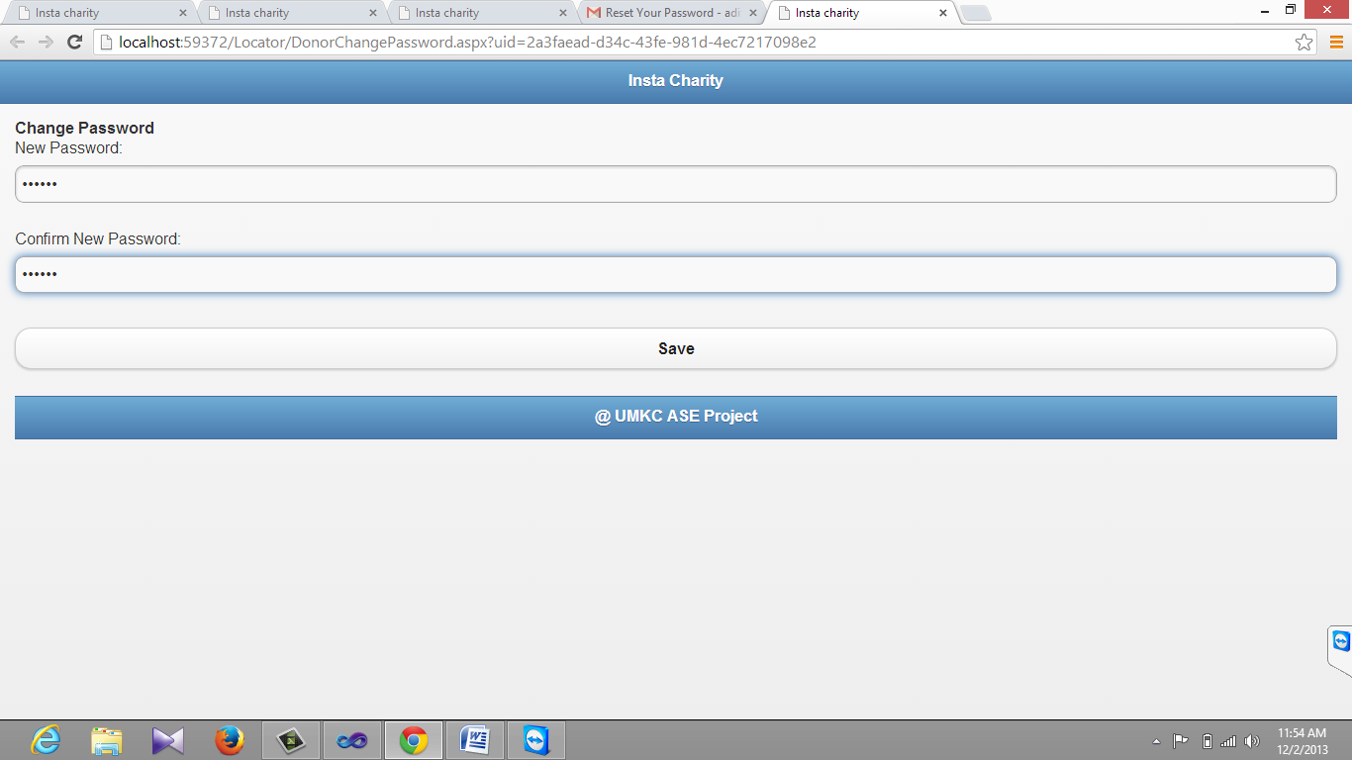

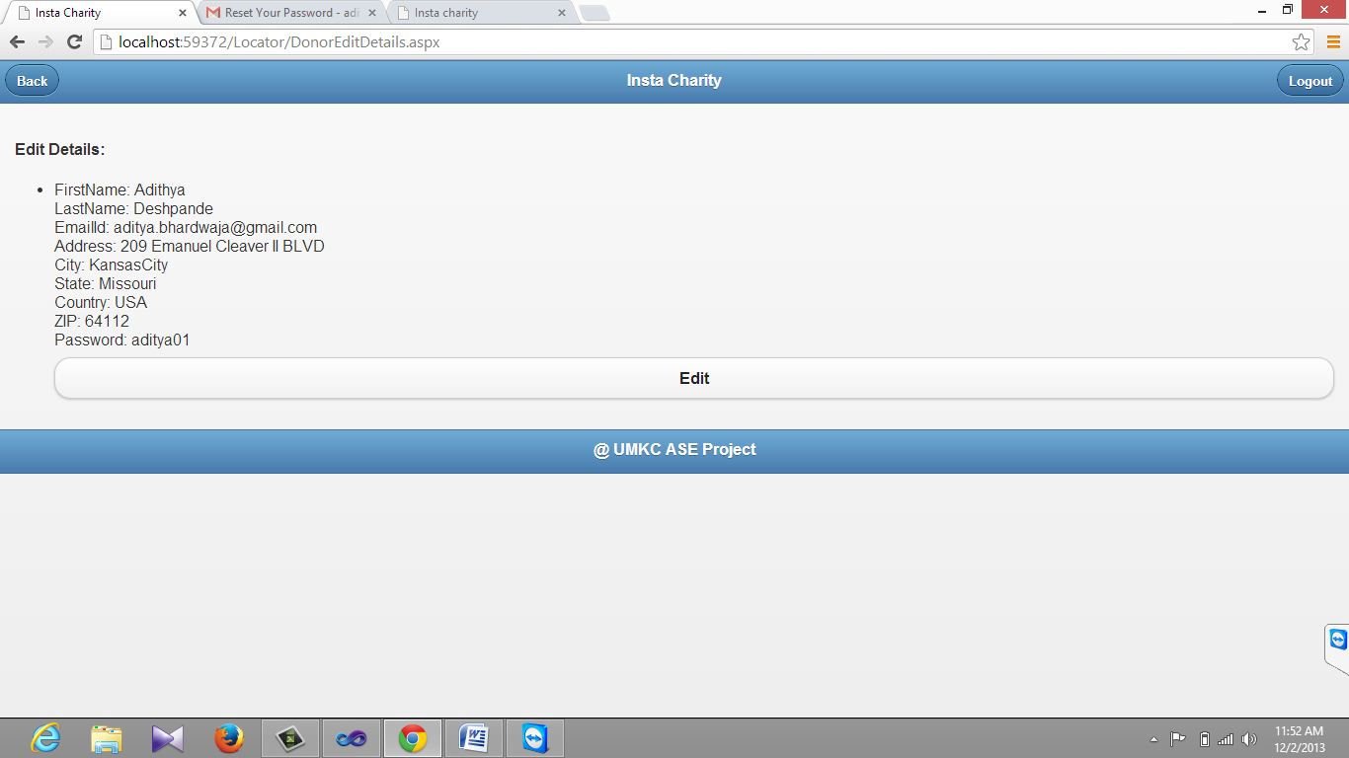

Above Screenshot indicates the change in password after password reset.

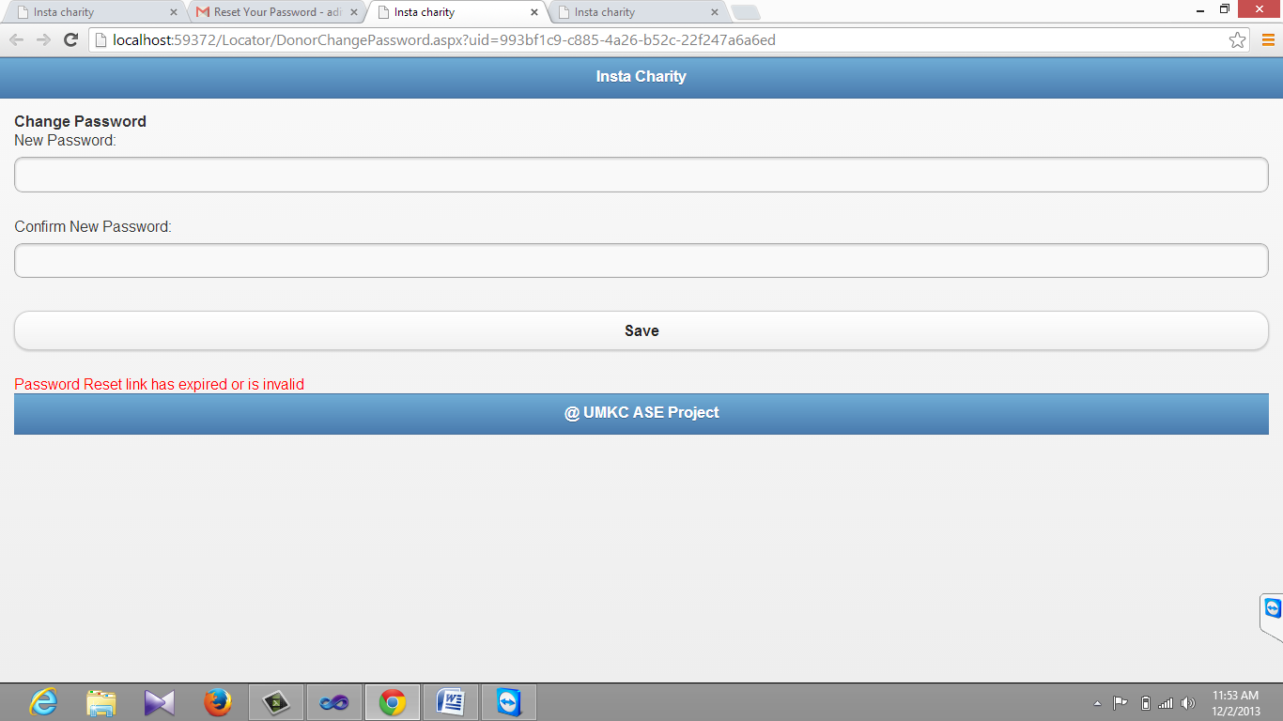

Once the password is changed using the mailed link. It won't work. If donor or organization clicks on the link again, error message will be appeared

Add Events

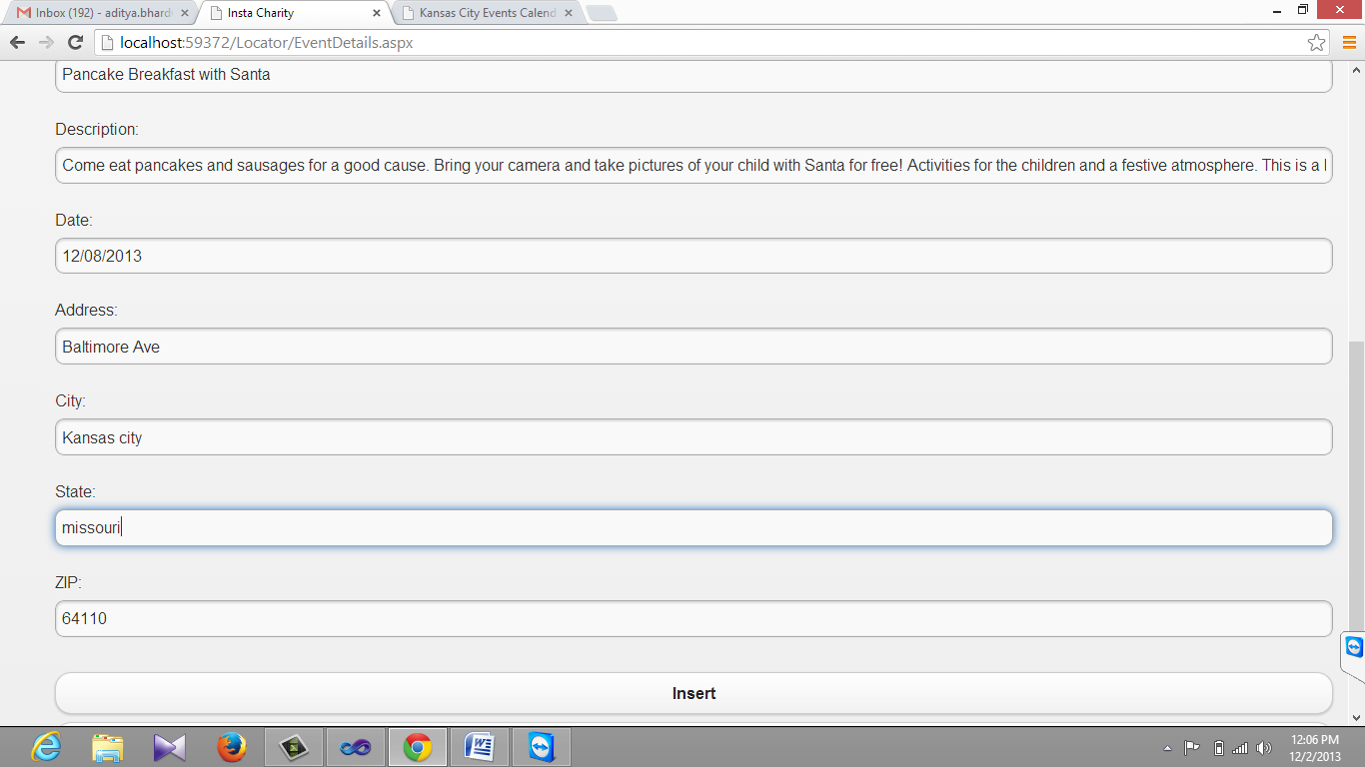

Organization can add events on the events page.

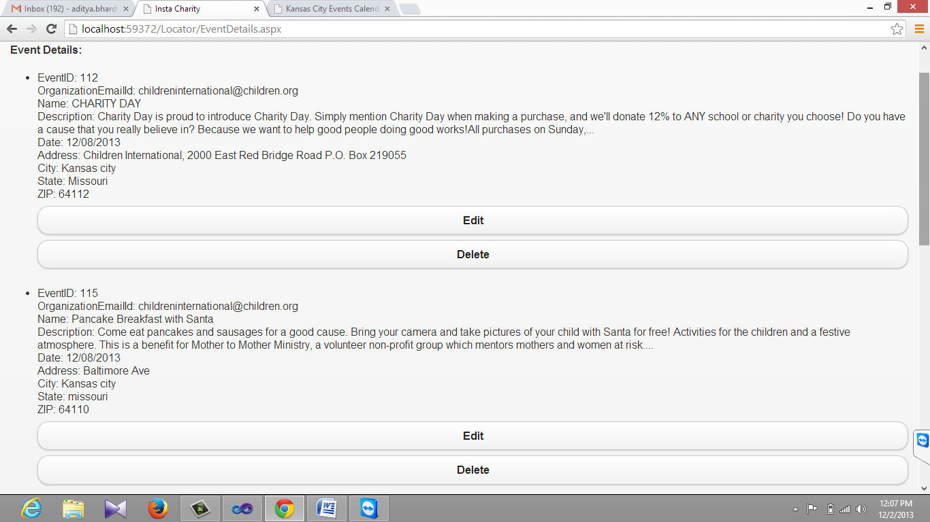

**Search NearBy Organizations:**

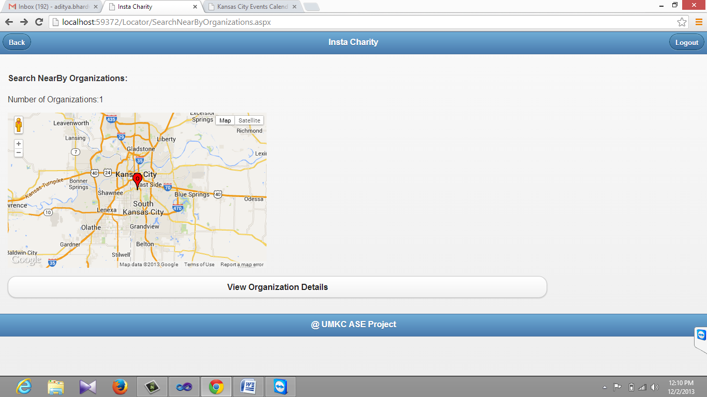

Donor can search for nearby organizations. Here we used Host IP API that detects the donors geo location and points the organizations registered with instacharity website on google maps.

**Search NearByEvents:**

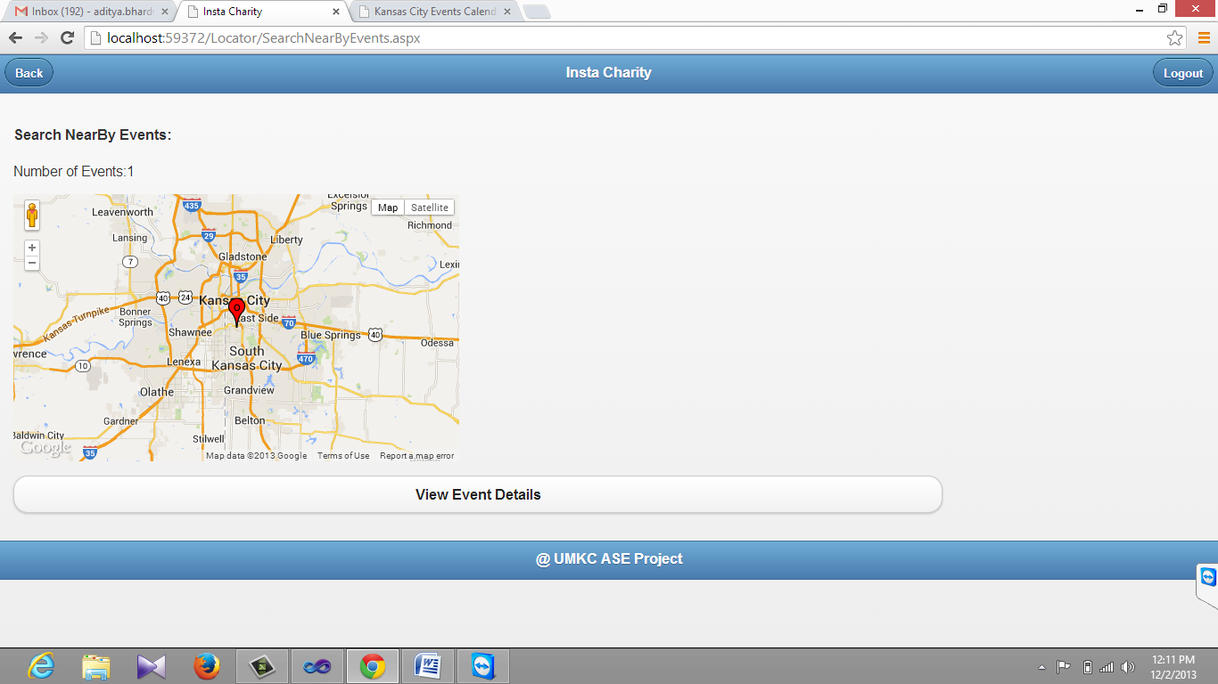

Like search by organizations donor can also search nearby events.

**Event Status:**

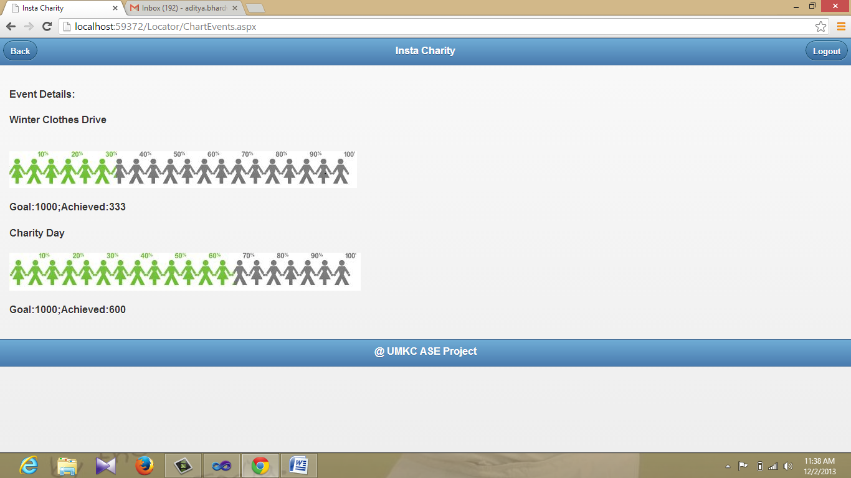

Fund status of the events will be displayed in the event status tab.

**View Events:**

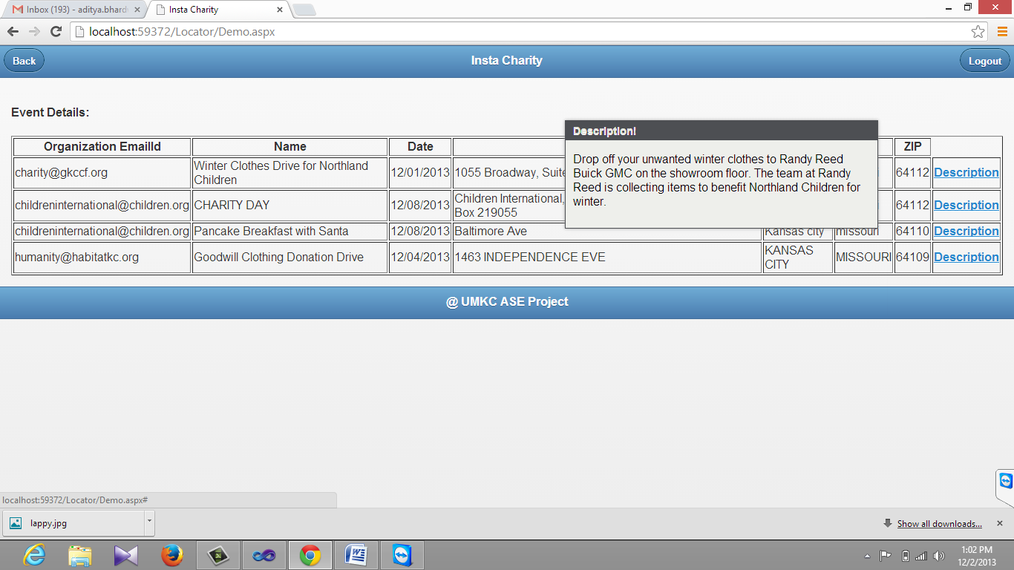

Donor can view all events posted by the organizations. They can view the description of the events when they hover on the description option. We used JQuery POP up to enable this feature.

View Organizations:

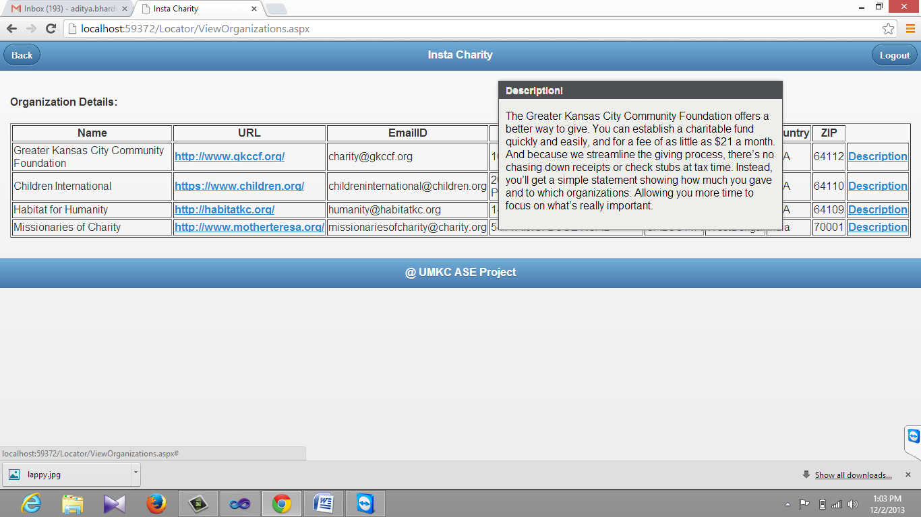

Donor can view all organizations registered with the website. They can view the description of the organization when they hover on the description option. We used JQuery POP up to enable this feature.

**Give Away:**

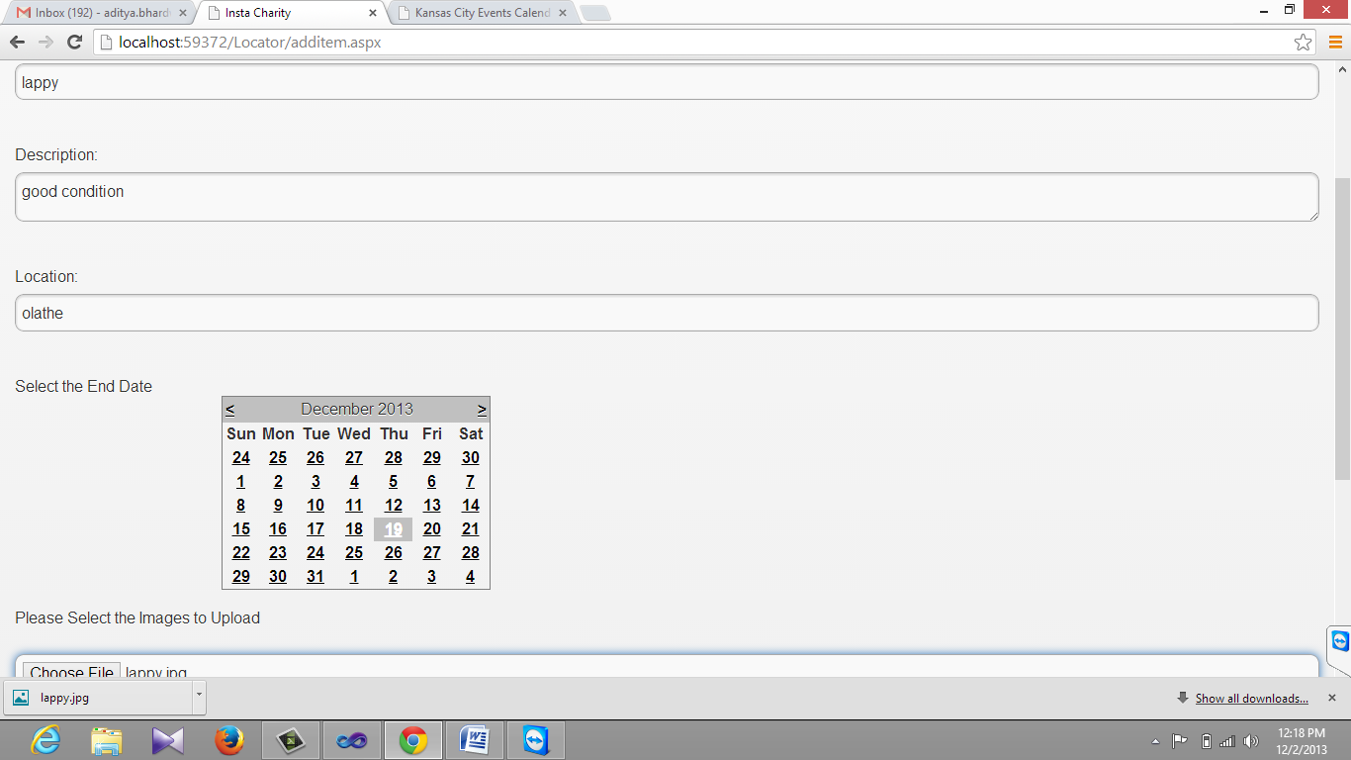

Donors or organizations can upload information regarding the items in give away tab. They can set time limit to give away the item.

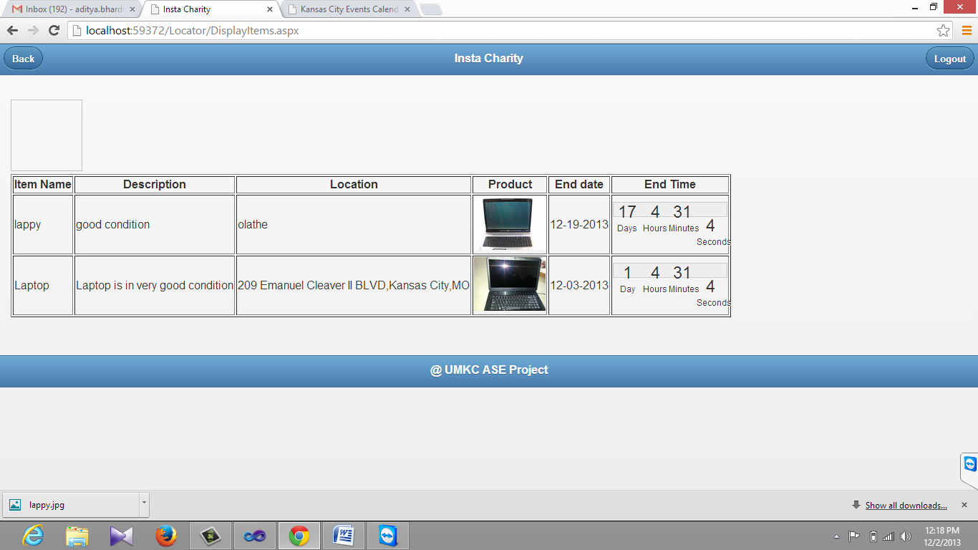

Donors/organizations can view give away items uploaded by co donors / organizations.

**Upload Videos By Organization**

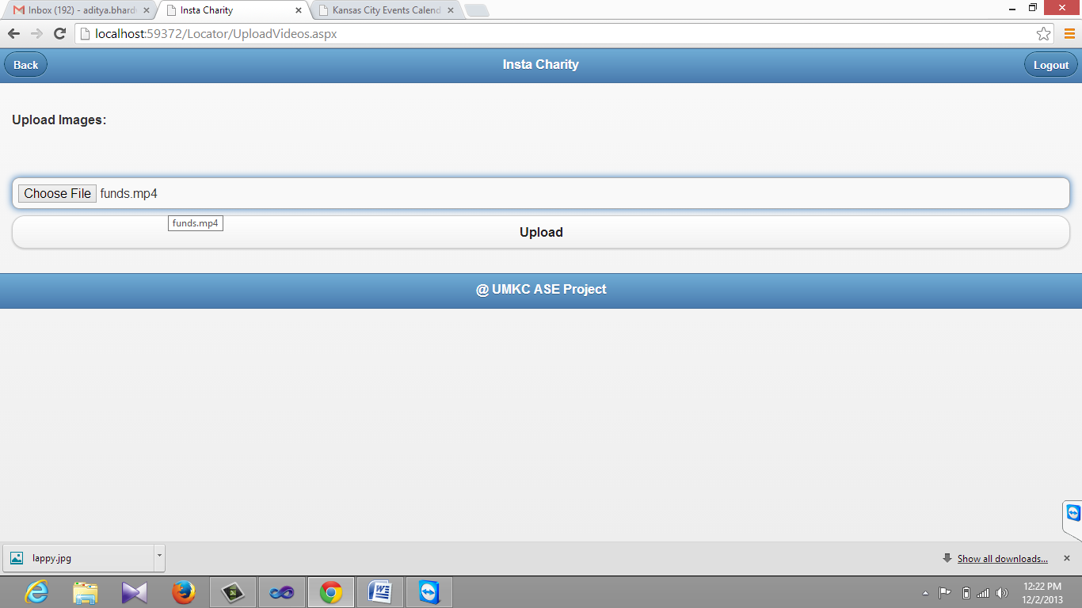

Organizations can Upload videos regarding events or social causes to the website through this feature

**View Videos:**

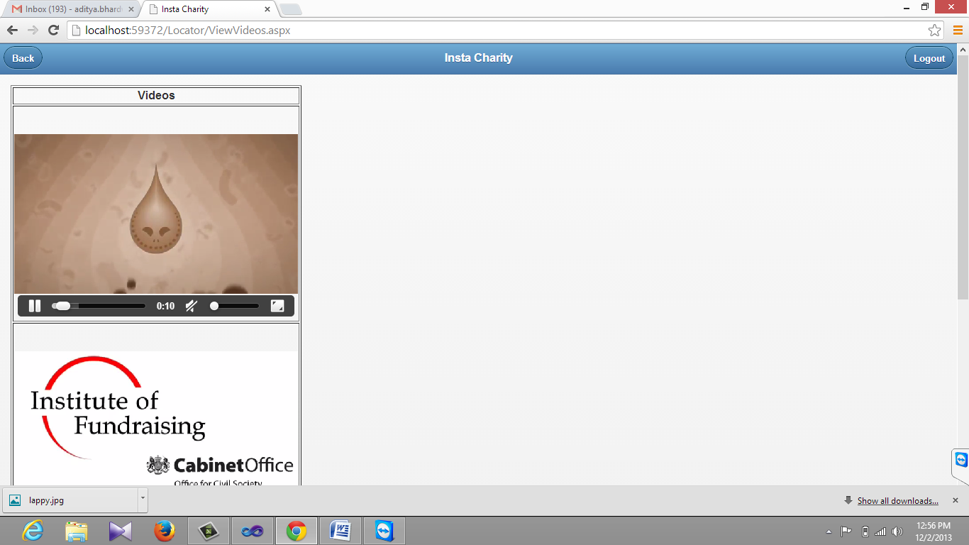

Donor can view the videos uploaded by the organizations through this feature.

**Project Video Link:**

<https://www.youtube.com/watch?v=9kF1X0nT7Xo>

**Scrumdo:**

<http://www.scrumdo.com/organization/instacharity/dashboard>

**Contribution:**

Aditya Deshpande- Search Nearby organizations/events. Upload videos and view videos. Event status.

Tej Kiran Meka- Password Reset, UI design, database, Documentation.

Giresh- Give Away.

**Project Implementation/Status Report:**

By the end of the Increment 4 we have successfully completed our project.

**Issues/concerns:**

We have issues of deployment to cloud. We are able to display home page. But when we proceed further we got port errors . We are trying to resolve the issue before final project submission.